---------------------------------------------------------------------

-- LAB 06

--

-- Exercise 4

---------------------------------------------------------------------

USE TSQL;

GO

---------------------------------------------------------------------

-- Task 1

--

-- Write a SELECT statement to retrieve the contactname column from the Sales.Customers table. Based on this column, add a calculated column named lastname, which should consist of all the characters before the comma.

--

-- Execute the written statement and compare the results that you got with the recommended result shown in the file 82 - Lab Exercise 4 - Task 1 Result.txt.

---------------------------------------------------------------------

Select lastName = SUBSTRING(sc.contactname,1,CHARINDEX(',',sc.contactname,1))

From Sales.Customers as sc

Select sc.contactname From Sales.Customers sc

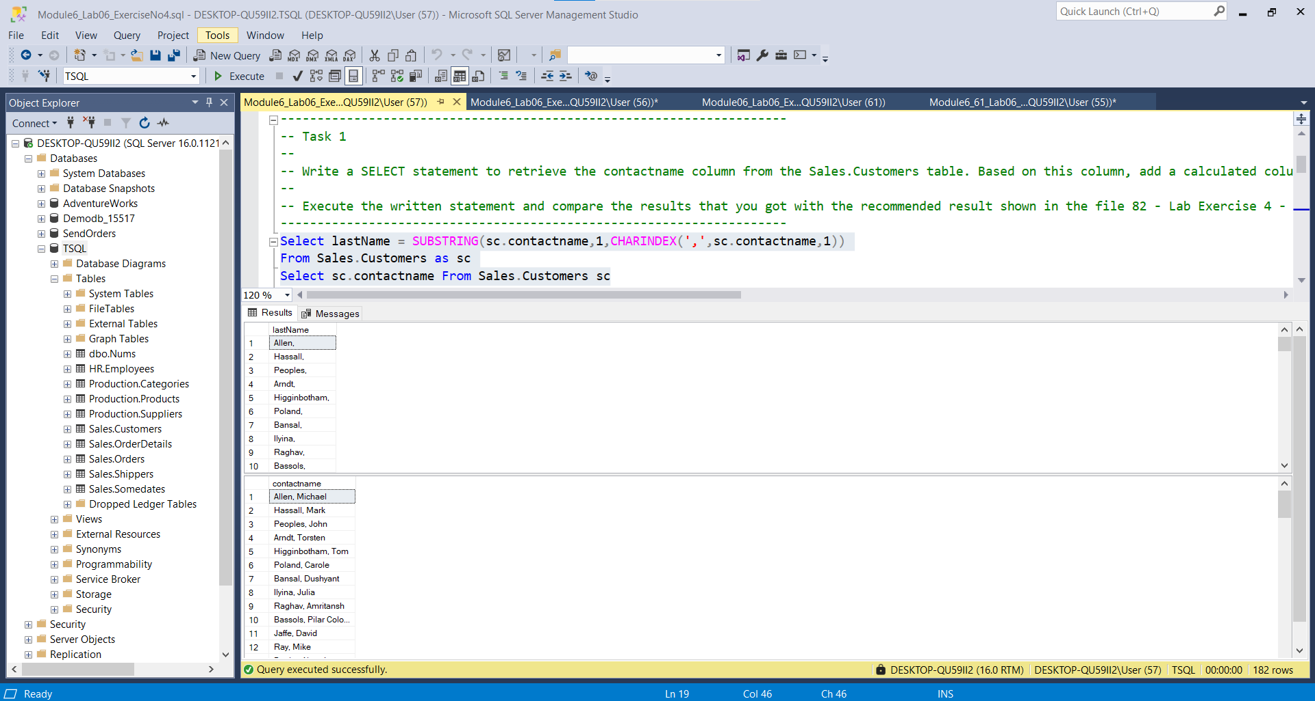

---------------------------------------------------------------------

-- Task 2

--

-- Write a SELECT statement to retrieve the contactname column from the Sales.Customers table and replace the comma in the contact name with an empty string. Based on this column, add a calculated column named firstname, which should consist of all the characters after the comma.

--

-- Execute the written statement and compare the results that you got with the recommended result shown in the file 83 - Lab Exercise 4 - Task 2 Result.txt.

---------------------------------------------------------------------

Select FirstName = Replace(SUBSTRING(sc.contactname,1,CHARINDEX(',',sc.contactname,1)),',','')

From Sales.Customers as sc

Select sc.contactname From Sales.Customers sc

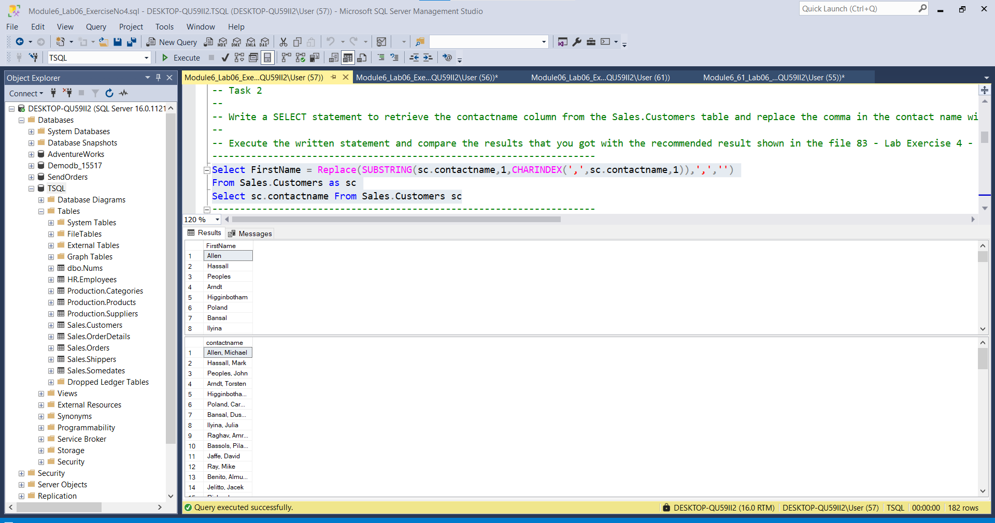

---------------------------------------------------------------------

-- Task 3

--

--1 Write a SELECT statement to retrieve the custid column from the Sales.Customers table.

--2 Add a new calculated column to create a string representation of the custid as a fixed-width (6 characters) customer code prefixed

-- with the letter C and leading zeros. For example, the custid value 1 should look like C00001.

--3 Execute the written statement and compare the results that you got with the recommended result shown in the file 84 - Lab Exercise 4 - Task 3 Result.txt.

---------------------------------------------------------------------

--1-

Select sc.custid FROM Sales.Customers as sc

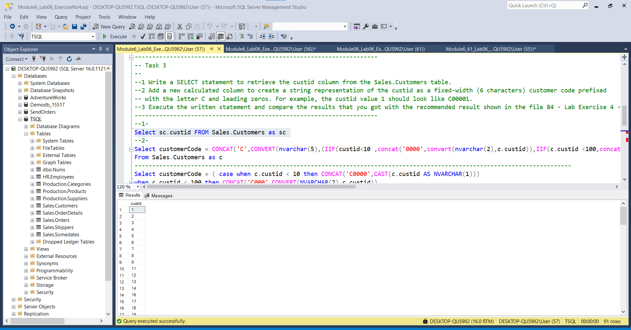

--2-

Select customerCode = CONCAT('C',CONVERT(nvarchar(5),(IIF(custid<10 ,concat('0000',convert(nvarchar(2),c.custid)),IIF(c.custid <100,concat('000',convert(nvarchar(1),custid))))))

From Sales.Customers as c

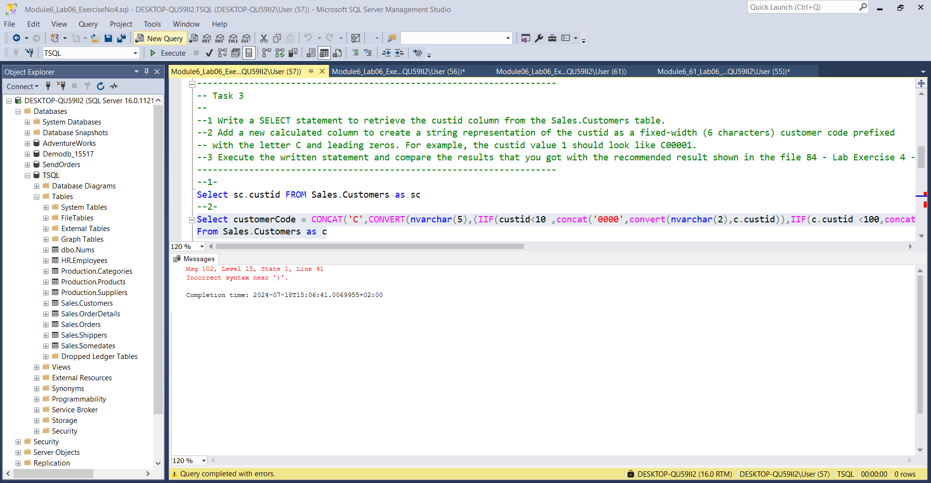

Përse nuk ekzekutohet?!!!!!!!!!!!!!!

----------------------------------------------------------------------------------------------------------------------------

Select c.custid,customerCode = ( case when c.custid < 10 then CONCAT('C0000',CAST(c.custid AS NVARCHAR(1)))

when c.custid < 100 then CONCAT('C000',CONVERT(NVARCHAR(2),c.custid))

ELSE '' END )

FROM Sales.Customers c

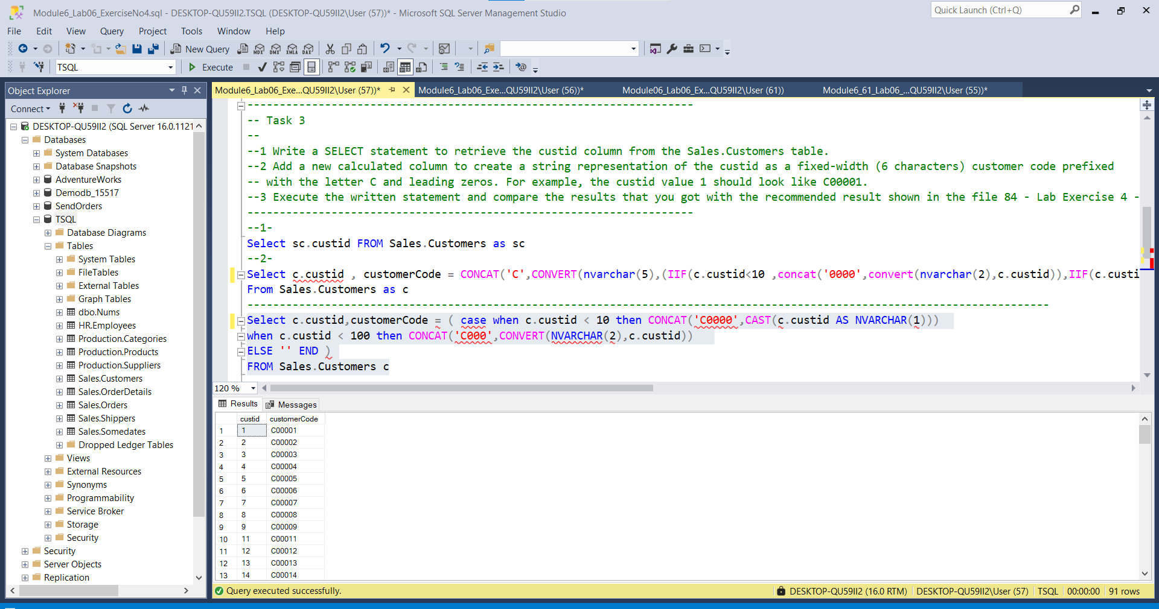

---------------------------------------------------------------------

-- Task 4

--

--1- Write a SELECT statement to retrieve the contactname column from the Sales.Customers table.

--2- Add a calculated column, which should count the number of occurrences of the character ‘a’ inside the contact name.

--3- (Hint: Use the string functions REPLACE and LEN.) Order the result from rows with the highest occurrences to lowest.

-- Execute the written statement and compare the results that you got with the recommended result shown in the file 85 - Lab Exercise 4 - Task 4 Result.txt.

--1-

Select sc.contactname

From Sales.Customers as sc

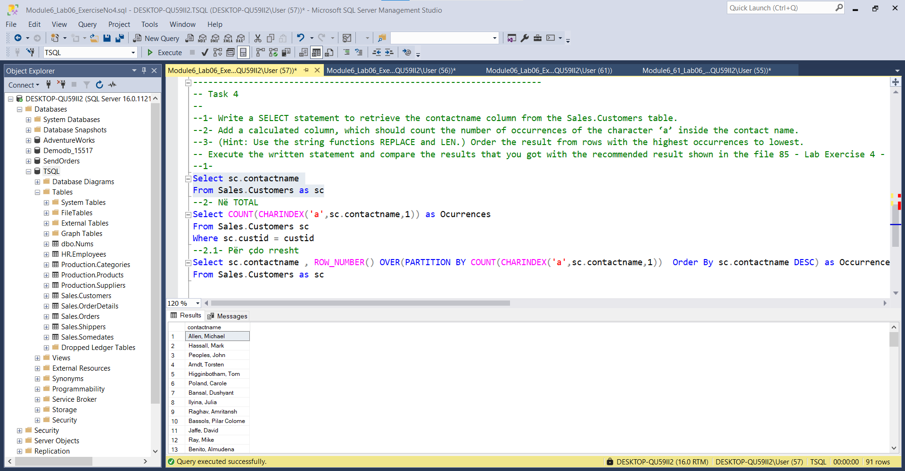

--2- Në TOTAL

Select COUNT(CHARINDEX('a',sc.contactname,1)) as Ocurrences

From Sales.Customers sc

Where sc.custid = custid

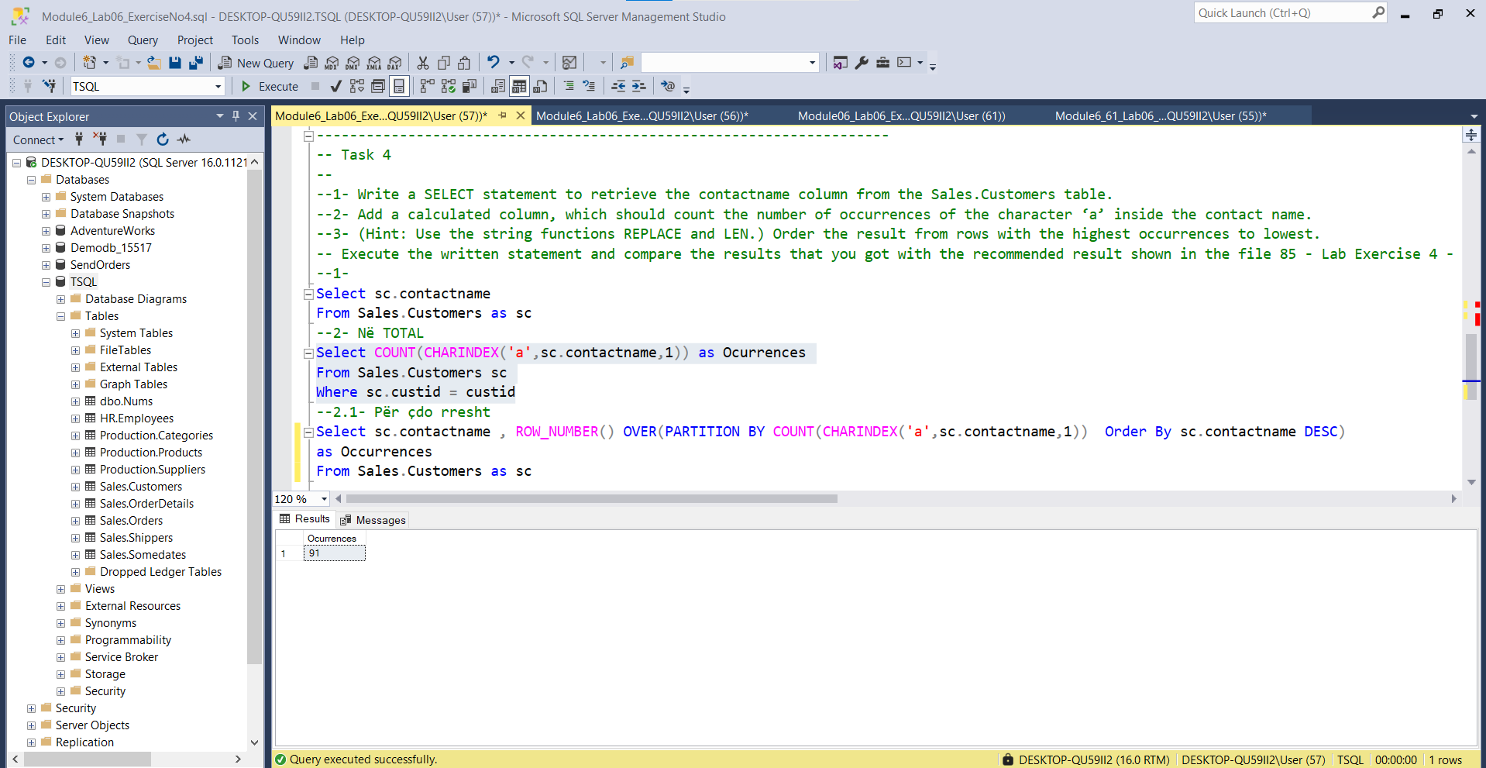

--2.1- Për çdo rresht

Select sc.contactname , ROW_NUMBER() OVER(PARTITION BY COUNT(CHARINDEX('a',sc.contactname,1)) Order By sc.contactname DESC) as Occurrences

From Sales.Customers as sc

---------------------------------------------------------------------

